Name: | Bodhisatya Ghosh
Class: | CSE DS
Batch: | B
UID: | 2021700026
Experiment: | 5

Aim: COVID-19 has put huge pressure on health systems. Many hospitals are running out of oxygen. Consider the scenario of a government hospital in Mumbai. You have to serve patient whose oxygen requirement is least at that moment. Read the input from user. Draw the Gantt chart. Calculate Waiting time, Turn around time, Completion time for each patient as well as average of each time entity.

Code:

#include <stdio.h>
#include <stdlib.h>

int Min(int arr[],int n)
{

int min=0;
for(int i=0;i<n;i++)
{
if(arr[i]<arr[min])
{
min=i;
}
}
return min;
}
void swap(int* a, int* b)
{
int temp = *a;
*a = *b;
*b = temp;
}

void sort(int arr[], int n)
{
int i, j, min;
for (i = 0; i < n - 1; i++)
{
min = i;
for (j = i + 1; j < n; j++)
if (arr[j] < arr[min])
min = j;
swap(&arr[min], &arr[i]);
}
}

void main()
{
int arrival[5];
//int req[5];
int sum=0;
int brSc[5];
int brArr[5];
int comp[5];
int start[5];
printf("Enter number of patients: 5\n");
for(int i=0;i<5;i++)
{
printf("Enter arrival time for patient %d: ",i+1);
scanf("%d",&arrival[i]);
}
for(int i=0;i<5;i++)
{
printf("Enter required time for patient %d: ",i+1);
scanf("%d",&brSc[i]);
sum+=brSc[i];
brArr[i]=10000;
}
printf("\n");
int rn=arrival[0];
int rnj=0;
sort(arrival,5);
for(int i=0;i<sum;i++)
{
for(int j=0;j<5;j++)
{
if(i==arrival[j])
{
brArr[j]=brSc[j];
}
}
if(rn==0)
{
comp[rnj]=i;
rnj=Min(brArr,5);
printf("%d-P%d-",i,rnj+1);
rn=brArr[rnj];
start[rnj]=i;
brArr[rnj]=1000;
}
rn--;
}
comp[rnj]=sum+arrival[0];
printf("%d\n\n",sum+arrival[0]);
printf("Process\tWT\tTAT\tCT\n");
for(int i=0;i<5;i++)
{
printf("%d\t%d\t%d\t%d\n",i+1,start[i]-arrival[i],comp[i]-arrival[i],comp[i]);
}
}

Output:
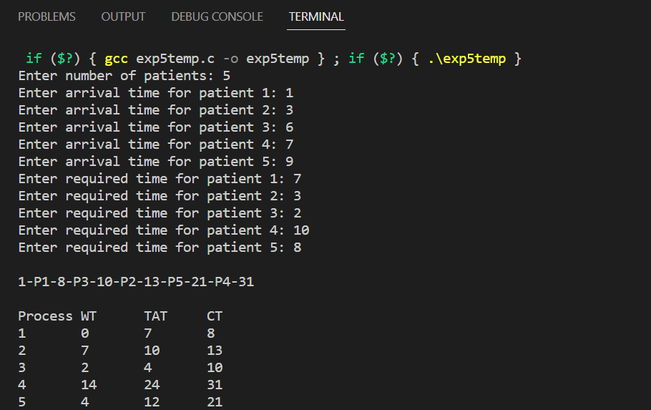
Conclusion: In this experiment, we have implemented Non-preemptive SJF scheduling to get the Gantt chart, Waiting Time, Turn Around Time and Completion Time

